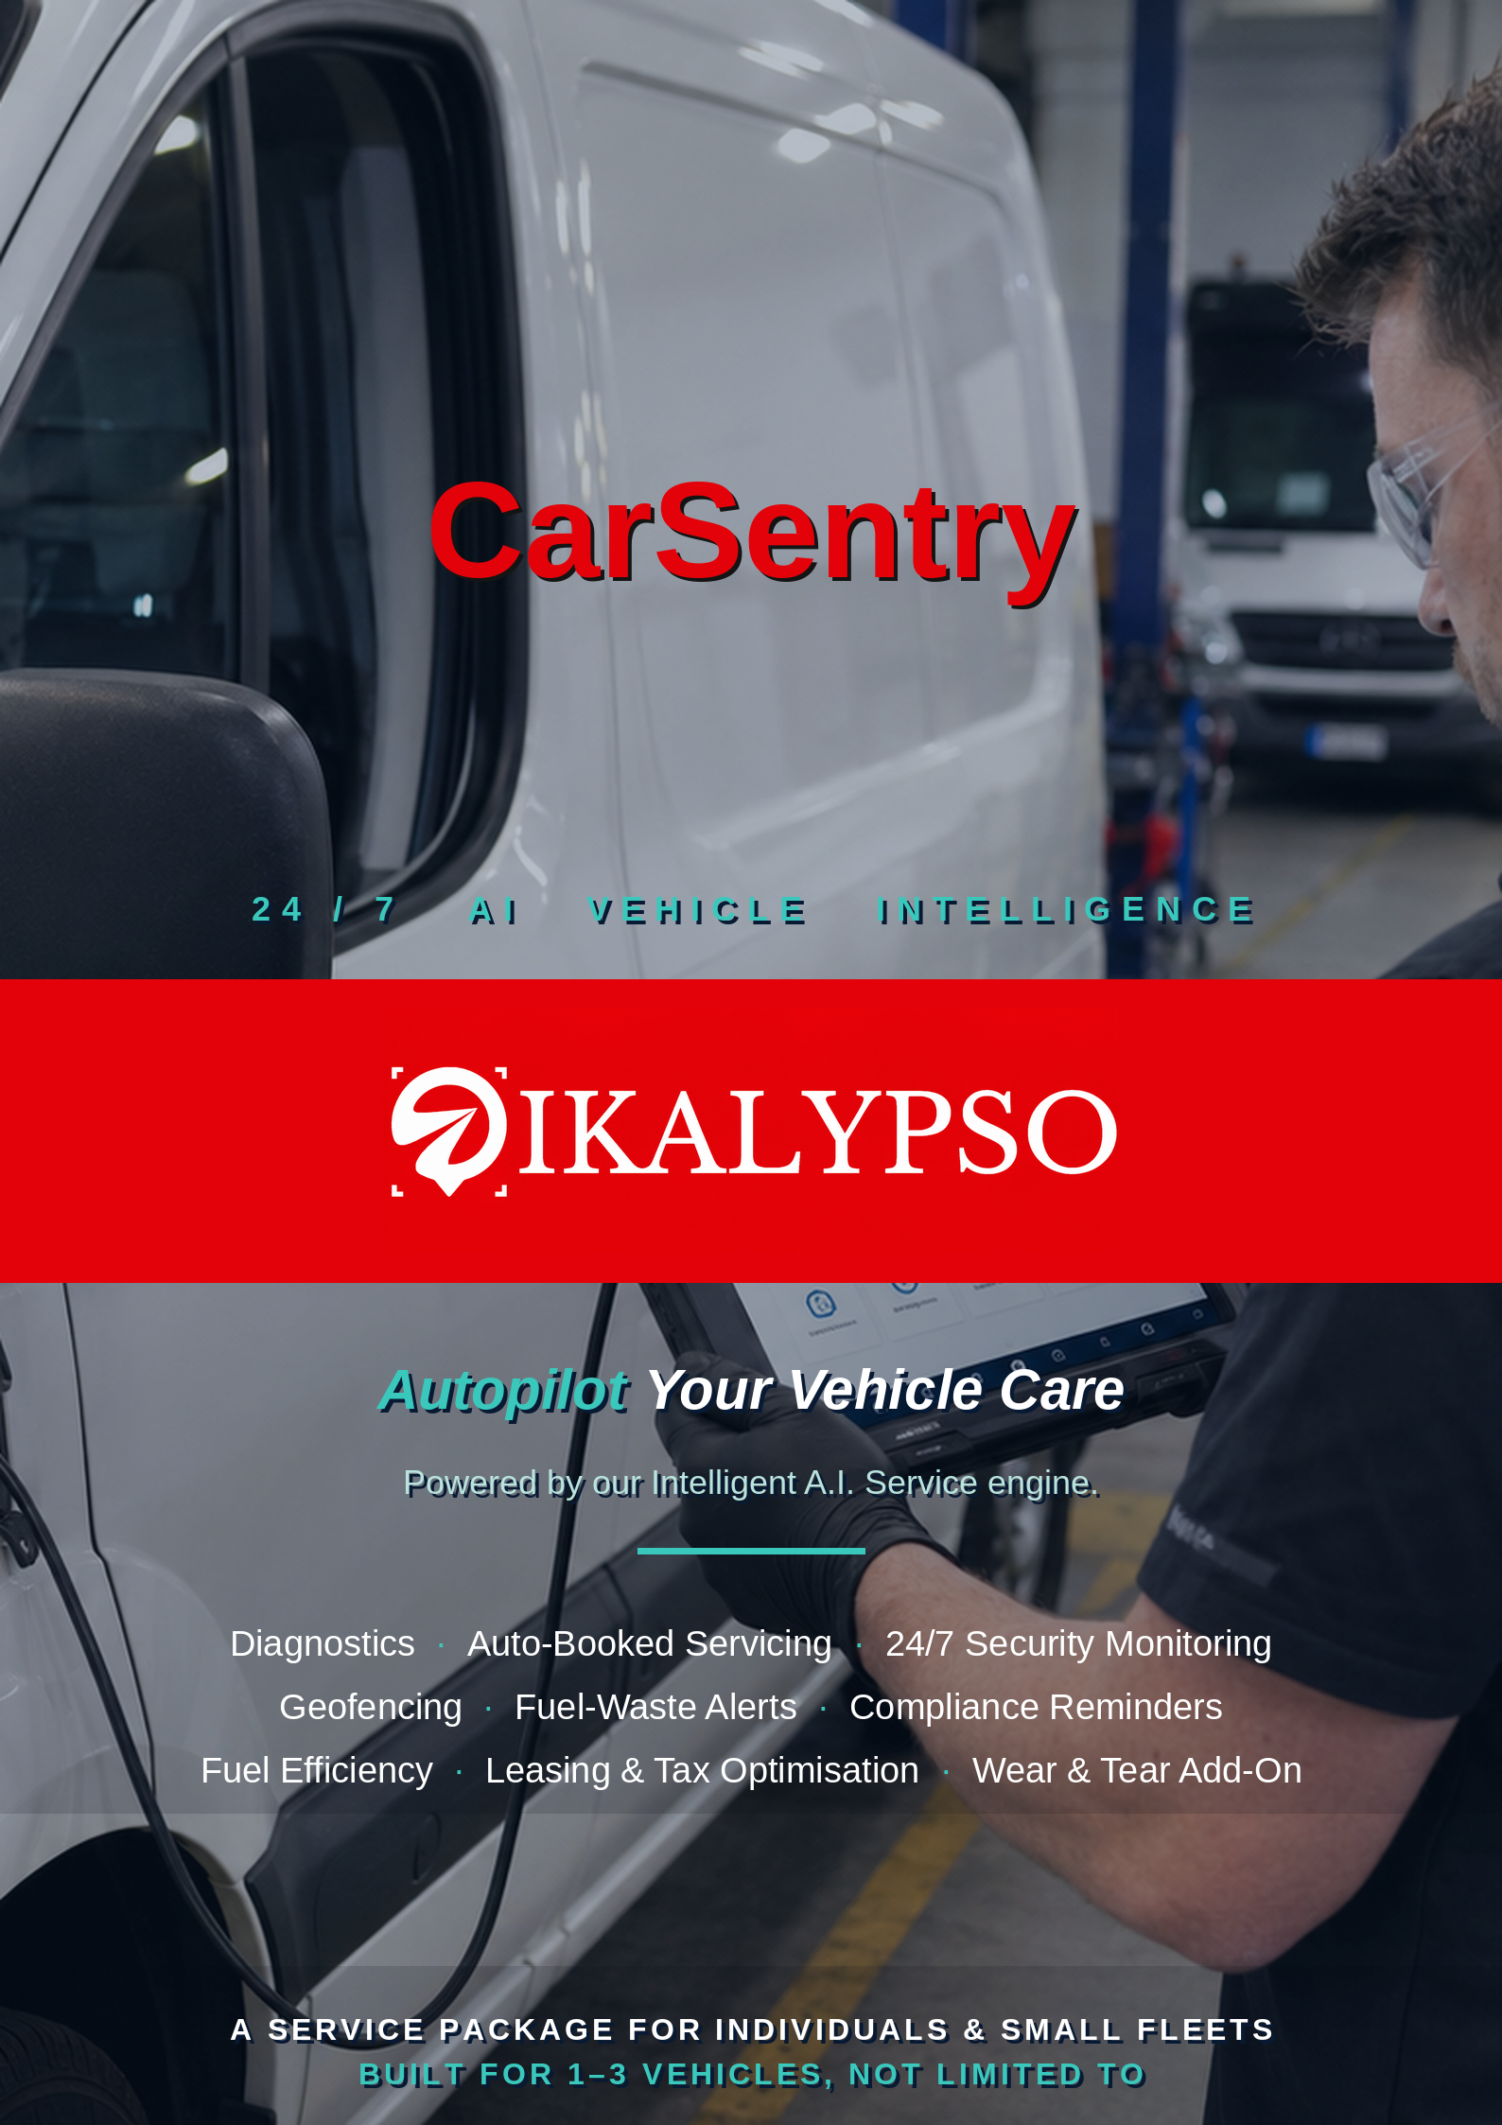


THE PROBLEM

Car ownership should be a delight and not a second job
Between tracking rego renewals, chasing insurance and eSafety dates, guessing at dashboard warning lights, and remembering to actually book the car in — vehicle upkeep quietly eats hours, and small mistakes cost real money in fines, breakdowns and lost resale value. For a household with two cars or a small business running three, it multiplies fast.

THE SOLUTION

A system that watches, decides, books and repairs — automatically
Ikalypso's CarSentry system runs on an Intelligent A.I. Service engine that connects to your vehicle's onboard diagnostics (DTC) and telemetry, continuously reading engine, emissions and performance data in the background. The moment a fault code or irregular behaviour appears, the Intelligent A.I. Service interprets it, matches it to your nominated mechanic or service centre, and books the appointment — before it becomes a breakdown. No app-checking, no phone calls, no guesswork.

24/7  Live monitoring | 100%  Automated bookings | 1–3+  Vehicles covered  targeted, not capped | 0  Missed renewals

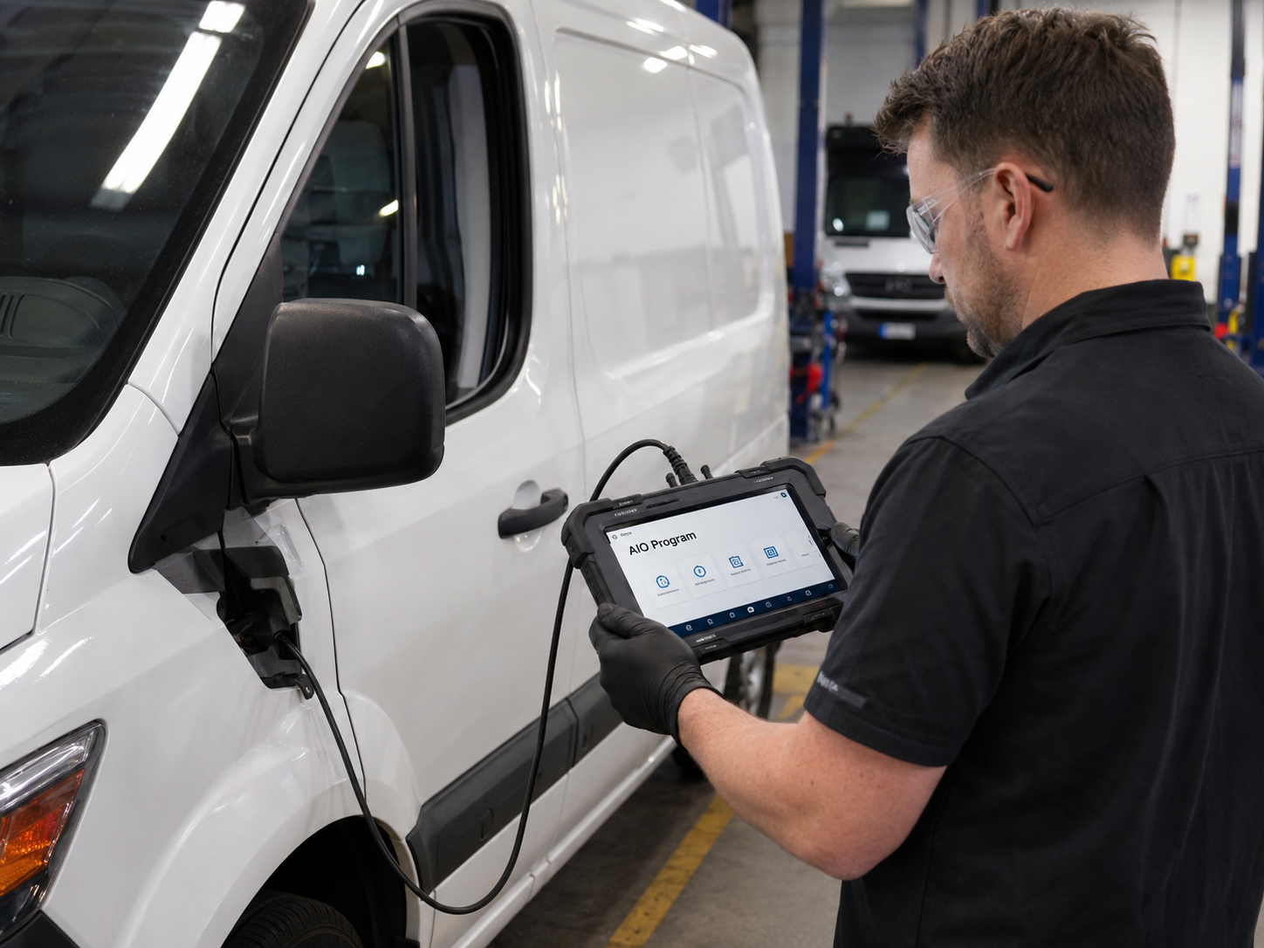  Fault codes read straight from the vehicle, matched by our Intelligent A.I. Service to the right fix and the right centre. | BEYOND THE WORKSHOP VISIT  Diagnosis, without the drive-in  Through connected IoT telemetry, fault diagnosis is no longer limited to an on-site inspection. Our Intelligent A.I. Service continuously monitors and analyses thousands of DTC error codes in real time, surfacing exactly which fault or concern needs attention and guiding the vehicle back to optimum, on-road performance — long before it would otherwise be caught on a workshop visit.

15,000+  DTC error codes recognised & analysed | Real-time  Fault interpretation, not periodic checks | IoT-connected  No on-site inspection required to diagnose

HOW IT WORKS

Eight systems, working as one
01 | AI Diagnostic & Telemetry Monitoring  We continuously read your vehicle's DTC (diagnostic trouble codes) and live telemetry — engine health, emissions, battery, sensor behaviour. Anomalies are triaged by AI in real time, not left to flash a dashboard light you might not notice.
02 | Automated Service Booking  When a fault or service milestone is detected, Ikalypso books the appointment directly with your nominated mechanic or service centre — matched to the fault type, your location and their availability. You get a notification, not a task.
03 | 24/7 Security, Geofencing & Fuel-Waste Monitoring  Set safe zones for home, work, or your fleet depot and get instant alerts if a vehicle leaves them unexpectedly. Every vehicle's live location is available on demand, 24/7. The same feed flags unusual fuel expenditure — extended idling, off-hours movement, or driving patterns that don't match normal use — so you're alerted to waste or unauthorised use as it happens, not at the next fuel-up.
04 | Compliance & Renewal Reminders  Rego, insurance and eSafety check dates are tracked automatically. Ikalypso alerts you well ahead of due dates — and where linked to your nominated provider, can trigger the renewal or booking itself.
05 | Fuel Efficiency & Performance Optimisation  Driving and diagnostic patterns are analysed to flag issues that quietly drain fuel economy — underinflated tyres, misfires, sensor drift — so repairs happen while they're still cheap, and your engine stays at optimum performance.
06 | Wear & Tear Cover — Optional Add-On  Tyres, brakes, wipers, batteries and filters are tracked against real usage data, not just a calendar. Every Ikalypso plan includes the alerts and scheduling for free; add Wear & Tear Cover to fold the parts and labour cost itself into one flat monthly top-up through your nominated centre.
07 | Leasing & Tax Bundling  For employees and small businesses, Ikalypso — including monitoring, servicing and wear & tear cover — can be bundled into your novated lease or fleet running costs as one line item, structured to help maximise your tax position.
08 | Full Log Book & Service History  Every service, fault and repair is captured automatically into one digital log book — accurate, always up to date, and ready to export for resale, audits or warranty claims, without a single paper receipt to chase.

SERVICE PACKAGES

Uno, Due, Tre — three levels of CarSentry service
Every CarSentry tier includes the same core intelligence — DTC monitoring, AI-triaged fault detection and automated booking with your nominated service centre. Higher levels add live tracking, geofencing, fuel-waste alerts, compliance reporting and tax-optimised bundling as your needs grow. Wear & Tear Cover sits outside these tiers entirely, as an optional add-on.
PRICES SHOWN IN AUSTRALIAN DOLLARS · TAP A CURRENCY BELOW TO VIEW LIVE ON THE WEBSITE
A$ AUD |  | € EUR |  | £ GBP |  | $ USD

 | UNO  A$129pa | DUE  A$232pa | TRE  A$309pa
 | 1 car | 2 cars · A$116.00/car | 3 cars · A$103.00/car
Vehicles covered | 1 vehicle | Up to 2 vehicles | Up to 3 vehicles
DTC & telemetry monitoring | ✓ | ✓ | ✓
Automated service booking | ✓ | ✓ | ✓
24/7 location tracking | ✓ | ✓ | ✓
Geofence alerts | ✓ | ✓ | ✓
Fuel-waste & idle monitoring | ✓ | ✓ | ✓
Rego / insurance / eSafety reminders | ✓ | ✓ | ✓
Fuel & performance reports | Monthly | Monthly | Monthly
Nominated mechanic network | ✓ | ✓ | ✓
Leasing / tax bundling | + Optional | + Optional | + Optional
Priority breakdown response | + Optional | + Optional | + Optional
Full onboarding service | ✓ | ✓ | ✓
Wear & Tear Cover | + Optional | + Optional | + Optional
TRACKING & SECURITY
Route history & playback | ✓ | ✓ | ✓
Stolen vehicle recovery | ✓ | ✓ | ✓
ETA / arrival prediction | ✓ | ✓ | ✓
After-hours movement alerts | ✓ | ✓ | ✓
Tamper / disconnect alerts | ✓ | ✓ | ✓
Harsh braking, acceleration & cornering detection | ✓ | ✓ | ✓
Speeding alerts | ✓ | ✓ | ✓
Dashcam / ADAS/DMS | + Optional | + Optional | + Optional
DIAGNOSTICS & MAINTENANCE
Fault history & trend reporting | ✓ | ✓ | ✓
Predictive maintenance scheduling | ✓ | ✓ | ✓
Battery / voltage health monitoring | ✓ | ✓ | ✓
Engine hours tracking | ✓ | ✓ | ✓
Audit-ready fault history export | ✓ | ✓ | ✓
Digital log book — full service history | ✓ | ✓ | ✓
FUEL MANAGEMENT
Fuel consumption tracking | ✓ | ✓ | ✓
Fuel cost optimisation | ✓ | ✓ | ✓
Fuel theft / siphoning detection | ✓ | ✓ | ✓
COMPLIANCE & REPORTING
Full vehicle regulation monitoring | ✓ | ✓ | ✓
Route optimisation | ✓ | ✓ | ✓
CO2 / emissions reporting | ✓ | ✓ | ✓
Digital vehicle inspection (DVIR) checklists | ✓ | ✓ | ✓
ENTERPRISE
Multiple API access | ✓ | ✓ | ✓
Custom reporting & dashboards | ✓ | ✓ | ✓
OPTIONAL ADD-ONS — PRICED (ONCE BUY IS SELECTED)
Dashcam ADAS/DMS/GPS Sentinel | + Optional | + Optional | + Optional
Certified Installation of Vehicle Tracker + SIM + Pooled Data + Platform Sync | + Optional | + Optional | + Optional
Certified Installation of Vehicle DashCam + SIM + Pooled Data + Platform Sync | + Optional | + Optional | + Optional
DashCam Group Data Plans | + Optional | + Optional | + Optional
SIM Cards | + Optional | + Optional | + Optional
 | Buy UNO → | Buy DUE → | Buy TRE →

OPTIONAL ADD-ON
Wear & Tear Cover
Uno, Due and Tre are the core security, diagnostics and booking product. If you'd also like the cost of standard wear items covered, add Wear & Tear Cover on top: tyres, brakes, battery, wipers and filters — parts and labour — folded into one flat top-up through your nominated centre, in place of paying for each replacement as it happens.
Get a Quote |  | Speak to an Agent

Pricing shown is indicative and per annum — tap Buy above for the current live price and full checkout. Uno, Due and Tre are levels of service, not hard vehicle caps.

IN REAL TERMS

What this actually looks like for you
It's easy to list features. Here's what they add up to once Ikalypso's Intelligent A.I. Service is running quietly in the background of your day.
A DAY IN THE LIFE OF A CARSENTRY VEHICLE
7:14am — A brake pad wear sensor triggers on your delivery van, mid-route.
7:15am — Our Intelligent A.I. Service reads the code, cross-checks it against live telemetry, and rules out a false alarm.
7:16am — Your nominated workshop's availability is checked automatically and a slot is booked for Thursday afternoon.
7:17am — You get a two-line notification. The van keeps working. That's the entire time it cost you.
The tangible payoff
3–5 hrs  given back per vehicle, per month — no more chasing bookings, renewals or workshop calls. | 0  renewal surprises — rego, insurance and eSafety dates are flagged well ahead, not discovered at the roadside.
Caught early  Faults are flagged at the trouble-code stage, before a minor issue cascades into a major repair bill. | 1 login  One dashboard for every vehicle, every reminder and every invoice — instead of a folder, a calendar and a glovebox full of receipts.
Side by side
 | WITHOUT | WITH CARSENTRY
Warning lights | Guess, Google it, or hope it goes away | Diagnosed via DTC & AI, booked before it fails
Service dates | Tracked in your head or a calendar app | Monitored continuously, booked automatically
Rego / insurance | Sticky notes and last-minute scrambles | Flagged well ahead, every time
Where's the car? | No visibility once it's out of sight | Live location & geofence alerts, 24/7
Fuel waste | Discovered at the bowser, if at all | Flagged the moment it starts
Tax time | Paperwork spread across providers | One bundled line, novated-lease ready
Figures above are typical, illustrative ranges based on common ownership patterns — actual time and cost savings depend on your vehicles, usage and nominated service centre.

WHY IT MATTERS

Built around four outcomes
Save Time  No more chasing bookings, remembering renewal dates or diagnosing dashboard lights yourself — the system does it and tells you what happened. | Save Fuel Costs  Early detection of inefficiencies — tyres, sensors, misfires — keeps every vehicle running at optimum fuel economy.
Increase Efficiency  Fault codes are matched to the right fix and the right centre the first time, cutting downtime and repeat visits. | Save Hassle  One nominated mechanic, one dashboard, one notification stream — everything to do with owning a car, handled for you.

Ready to put your garage on autopilot?
Talk to us about setting up CarSentry, powered by Ikalypso, for your household or small business — including how novated lease bundling could be structured for your tax position.
customer-care@ikalypso.com · ikalypso.com.au
APPLY |  | Get a Quote |  | Speak to an Agent

